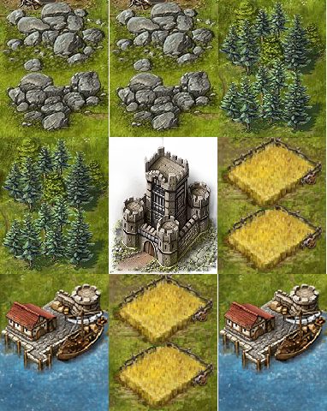

Arbitrary Constraints:
- Designed for mobile
- Shallow UI; Do not obfuscate information/actions
- Simple yet robust economy

High Level:
- 3x3 Grid with nine ‘nodes’
- Middle ‘node’ is users Castle/Hold
- Surround nodes are resource/town nodes
- Resource Nodes extract resources. X resources per Y seconds
- Resources go into bank/pool
- Resources spent on upgrades to resource extraction
- Each node has a finite number of resources in the node (perhaps regen based on current number + appointment)
- User has to manage consumption versus castle town growth

